Designed a battery
- TP14 (for charging )
- 3v to 7v converter
- Li-ion Cell
- Cell case
Circuit schematics
Features
- Change cell
- Charge
- Solar (A/N)
- System to identify dead cells (N/A)
Why we made Our Own
- Cost
- Size
- Cell change functionality
- Solar (N/A)

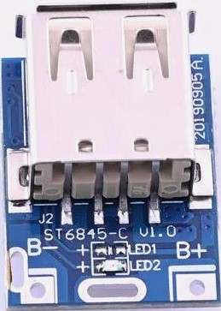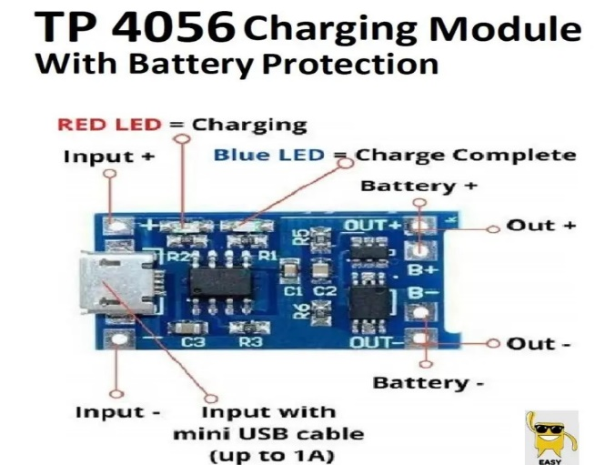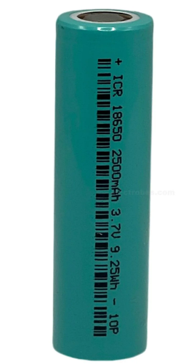

Lora module range test
- 2x Esp 32
- 2x Lora sx1278 module
- 1x Usb cable for programming
- 1x Led
- Breadboard
- Jumper wires
Sender Wire Connection’s
Lora | Esp32
GND | GND
3.3V | 3.3V
RST | PIN 4
D1O0 | PIN 13
NSS/CS/SS | PIN 5
MOSI | PIN 23
MISO | PIN 19
SCK | PIN 18
Receiver wire connection’s
Lora | Esp32
BOTH SIDE GND | GND
3.3V | 3.3V
RST | PIN 4
D1O0 | PIN 13
NSS/CS/SS | PIN 5
MOSI | PIN 23
MISO | PIN 19
SCK | PIN 18
LED | PIN 2
Sender side code
#include <SPI.h>
#include <LoRa.h>
#define lora_ss 5
#define lora_rst 4
#define lora_dio0 13
void setup() {
serial.begin(115200);
while (!serial);

// initialize lora module
lora.setpins(lora_ss, lora_rst, lora_dio0);
if (!lora.begin(433e6)) { // change to your lora module's frequency
serial.println("lora init failed. check your connections.");
while (true);
}
serial.println("lora sender initialized");
}
void loop() {
serial.println("sending packet...");
lora.beginpacket();
lora.print("hello");
lora.endpacket();
delay(1000); // wait 1 second before sending the next packet
}
Receiver side code
#include <SPI.h>
#include <LoRa.h>
#define LORA_SS 5
#define LORA_RST 4
#define LORA_DIO0 13
#define LED_PIN 2
void setup() {
Serial.begin(115200);
while (!Serial);
pinMode(LED_PIN, OUTPUT);
digitalWrite(LED_PIN, LOW);
// Initialize LoRa module
LoRa.setPins(LORA_SS, LORA_RST, LORA_DIO0);
if (!LoRa.begin(433E6)) { // Change to your LoRa module's frequency
Serial.println("LoRa init failed. Check your connections.");
while (true);
}
Serial.println("LoRa Receiver Initialized");
}
void loop() {
int packetSize = LoRa.parsePacket();
if (packetSize) {
String received = "";
while (LoRa.available()) {
received += (char)LoRa.read();
}
Serial.print("Received: ");
Serial.println(received);
// Blink LED when data is received
digitalWrite(LED_PIN, HIGH);
delay(100); // LED on for 100 ms
digitalWrite(LED_PIN, LOW);
} else {
// No data received, keep LED off
digitalWrite(LED_PIN, LOW);
}
}
Result of test : - 315m in open area

Lora module Temperature sensor
Sender Wire Connection’s
Lora | Esp32
GND | GND
3.3V | 3.3V
RST | PIN 4
D1O0 | PIN 13
NSS/CS/SS | PIN 5
MOSI | PIN 23
MISO | PIN 19
SCK | PIN 18
DHT22 | PIN 27
Receiver wire connection’s
Lora | Esp32
BOTH SIDE GND | GND
3.3V | 3.3V
RST | PIN 4
D1O0 | PIN 13
NSS/CS/SS | PIN 5
MOSI | PIN 23
MISO | PIN 19
SCK | PIN 18
LED | PIN 2

Sender side code
#include <SPI.h>
#include <LoRa.h>
#include <DHT.h>
#include <BluetoothSerial.h>

// LoRa pins
#define LORA_SS 5
#define LORA_RST 4
#define LORA_DIO0 13

// DHT22 pin and type
#define DHTPIN 27
#define DHTTYPE DHT22
DHT dht(DHTPIN, DHTTYPE);

// Bluetooth object
BluetoothSerial SerialBT;

void setup() {
Serial.begin(115200);
while (!Serial);

// Initialize DHT22
dht.begin();

// Initialize LoRa
LoRa.setPins(LORA_SS, LORA_RST, LORA_DIO0);
if (!LoRa.begin(433E6)) { // Change frequency based on your module
Serial.println("LoRa init failed. Check connections.");
while (true);
}

// Set LoRa parameters for maximum range
LoRa.setSpreadingFactor(12); // Maximum spreading factor
LoRa.setSignalBandwidth(125E3); // Narrow bandwidth
LoRa.setCodingRate4(8); // Maximum coding rate

Serial.println("LoRa Sender Initialized");

// Initialize Bluetooth
if (!SerialBT.begin("ESP32_Sender")) {
Serial.println("Bluetooth init failed.");
while (true);
}
Serial.println("Bluetooth Initialized as 'ESP32_Sender'");
}

void loop() {
// Read temperature and humidity from DHT22
float temperature = dht.readTemperature();
float humidity = dht.readHumidity();

// Handle DHT22 errors
if (isnan(temperature) || isnan(humidity)) {
Serial.println("Failed to read from DHT sensor!");
return;
}

// Prepare sensor data
String data = "Temp: " + String(temperature) + "°C, Hum: " + String(humidity) + "%";

// Send data over LoRa
Serial.println("Sending packet: " + data);
LoRa.beginPacket();
LoRa.print(data);
LoRa.endPacket();

// Send data over Bluetooth
SerialBT.println(data);

delay(2000); // Wait 2 seconds before next iteration
}
Receiver side code

#include <SPI.h>
#include <LoRa.h>
#include <BluetoothSerial.h>

// LoRa pins
#define LORA_SS 5
#define LORA_RST 4
#define LORA_DIO0 13

// LED pin
#define LED_PIN 2

// Bluetooth object
BluetoothSerial SerialBT;

void setup() {
Serial.begin(115200);
while (!Serial);

// Initialize LED
pinMode(LED_PIN, OUTPUT);
digitalWrite(LED_PIN, LOW);

// Initialize LoRa
LoRa.setPins(LORA_SS, LORA_RST, LORA_DIO0);
if (!LoRa.begin(433E6)) { // Change frequency based on your module
Serial.println("LoRa init failed. Check connections.");
while (true);
}

// Set LoRa parameters for maximum range
LoRa.setSpreadingFactor(12); // Maximum spreading factor
LoRa.setSignalBandwidth(125E3); // Narrow bandwidth
LoRa.setCodingRate4(8); // Maximum coding rate

Serial.println("LoRa Receiver Initialized");

// Initialize Bluetooth
if (!SerialBT.begin("ESP32_Receiver")) {
Serial.println("Bluetooth init failed.");
while (true);
}
Serial.println("Bluetooth Initialized as 'ESP32_Receiver'");
}

void loop() {
// Check for LoRa packet
int packetSize = LoRa.parsePacket();
if (packetSize) {
String received = "";
while (LoRa.available()) {
received += (char)LoRa.read();
}

Serial.print("Received via LoRa: ");
Serial.println(received);

// Blink LED to indicate data reception
digitalWrite(LED_PIN, HIGH);
delay(100);
digitalWrite(LED_PIN, LOW);

// Send data to Bluetooth
SerialBT.println(received);
}

// Check for Bluetooth input
if (SerialBT.available()) {
String bluetoothMessage = "";
while (SerialBT.available()) {
bluetoothMessage += (char)SerialBT.read();
}

Serial.print("Received via Bluetooth: ");
Serial.println(bluetoothMessage);

// Echo the Bluetooth message back
SerialBT.println("Echo: " + bluetoothMessage);
}

delay(10);
}

Result of test : - Successful And data can be extracted via Bluetooth serial terminal on android.

